CS 255 System Design Document Template

UML Diagrams

UML Use Case Diagram

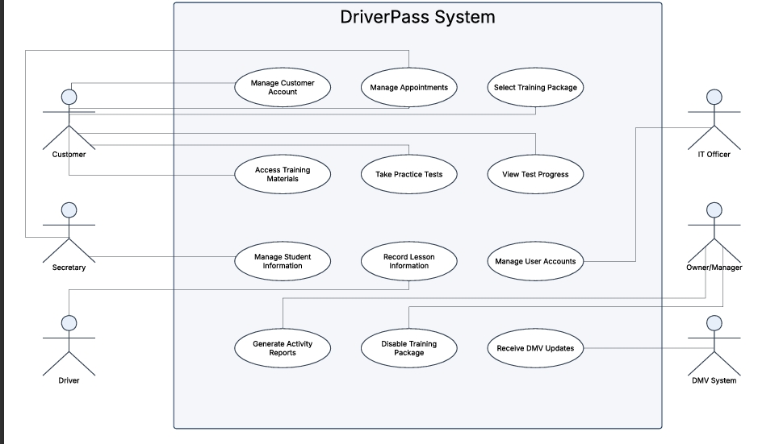

UML Activity Diagrams

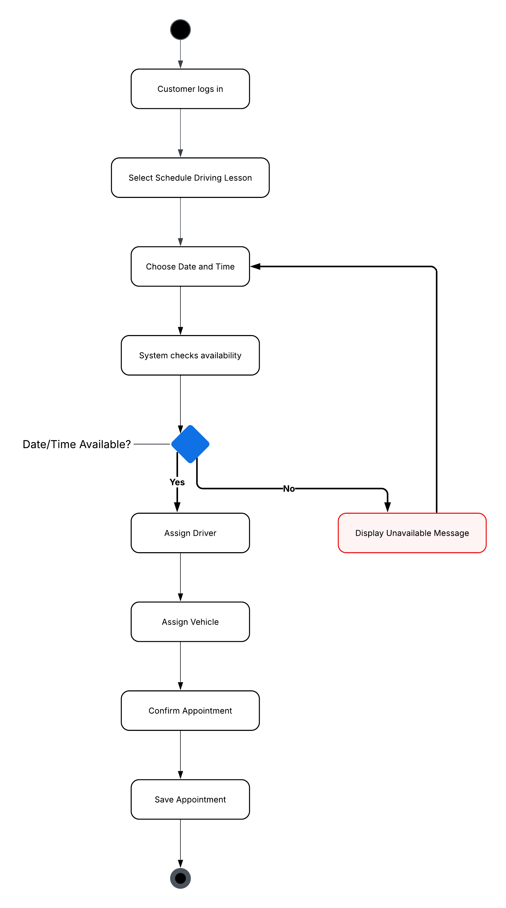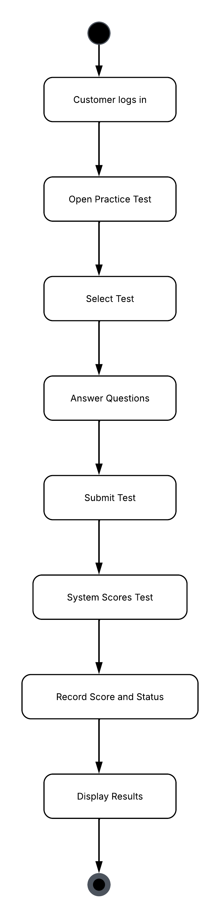

UML Sequence Diagram

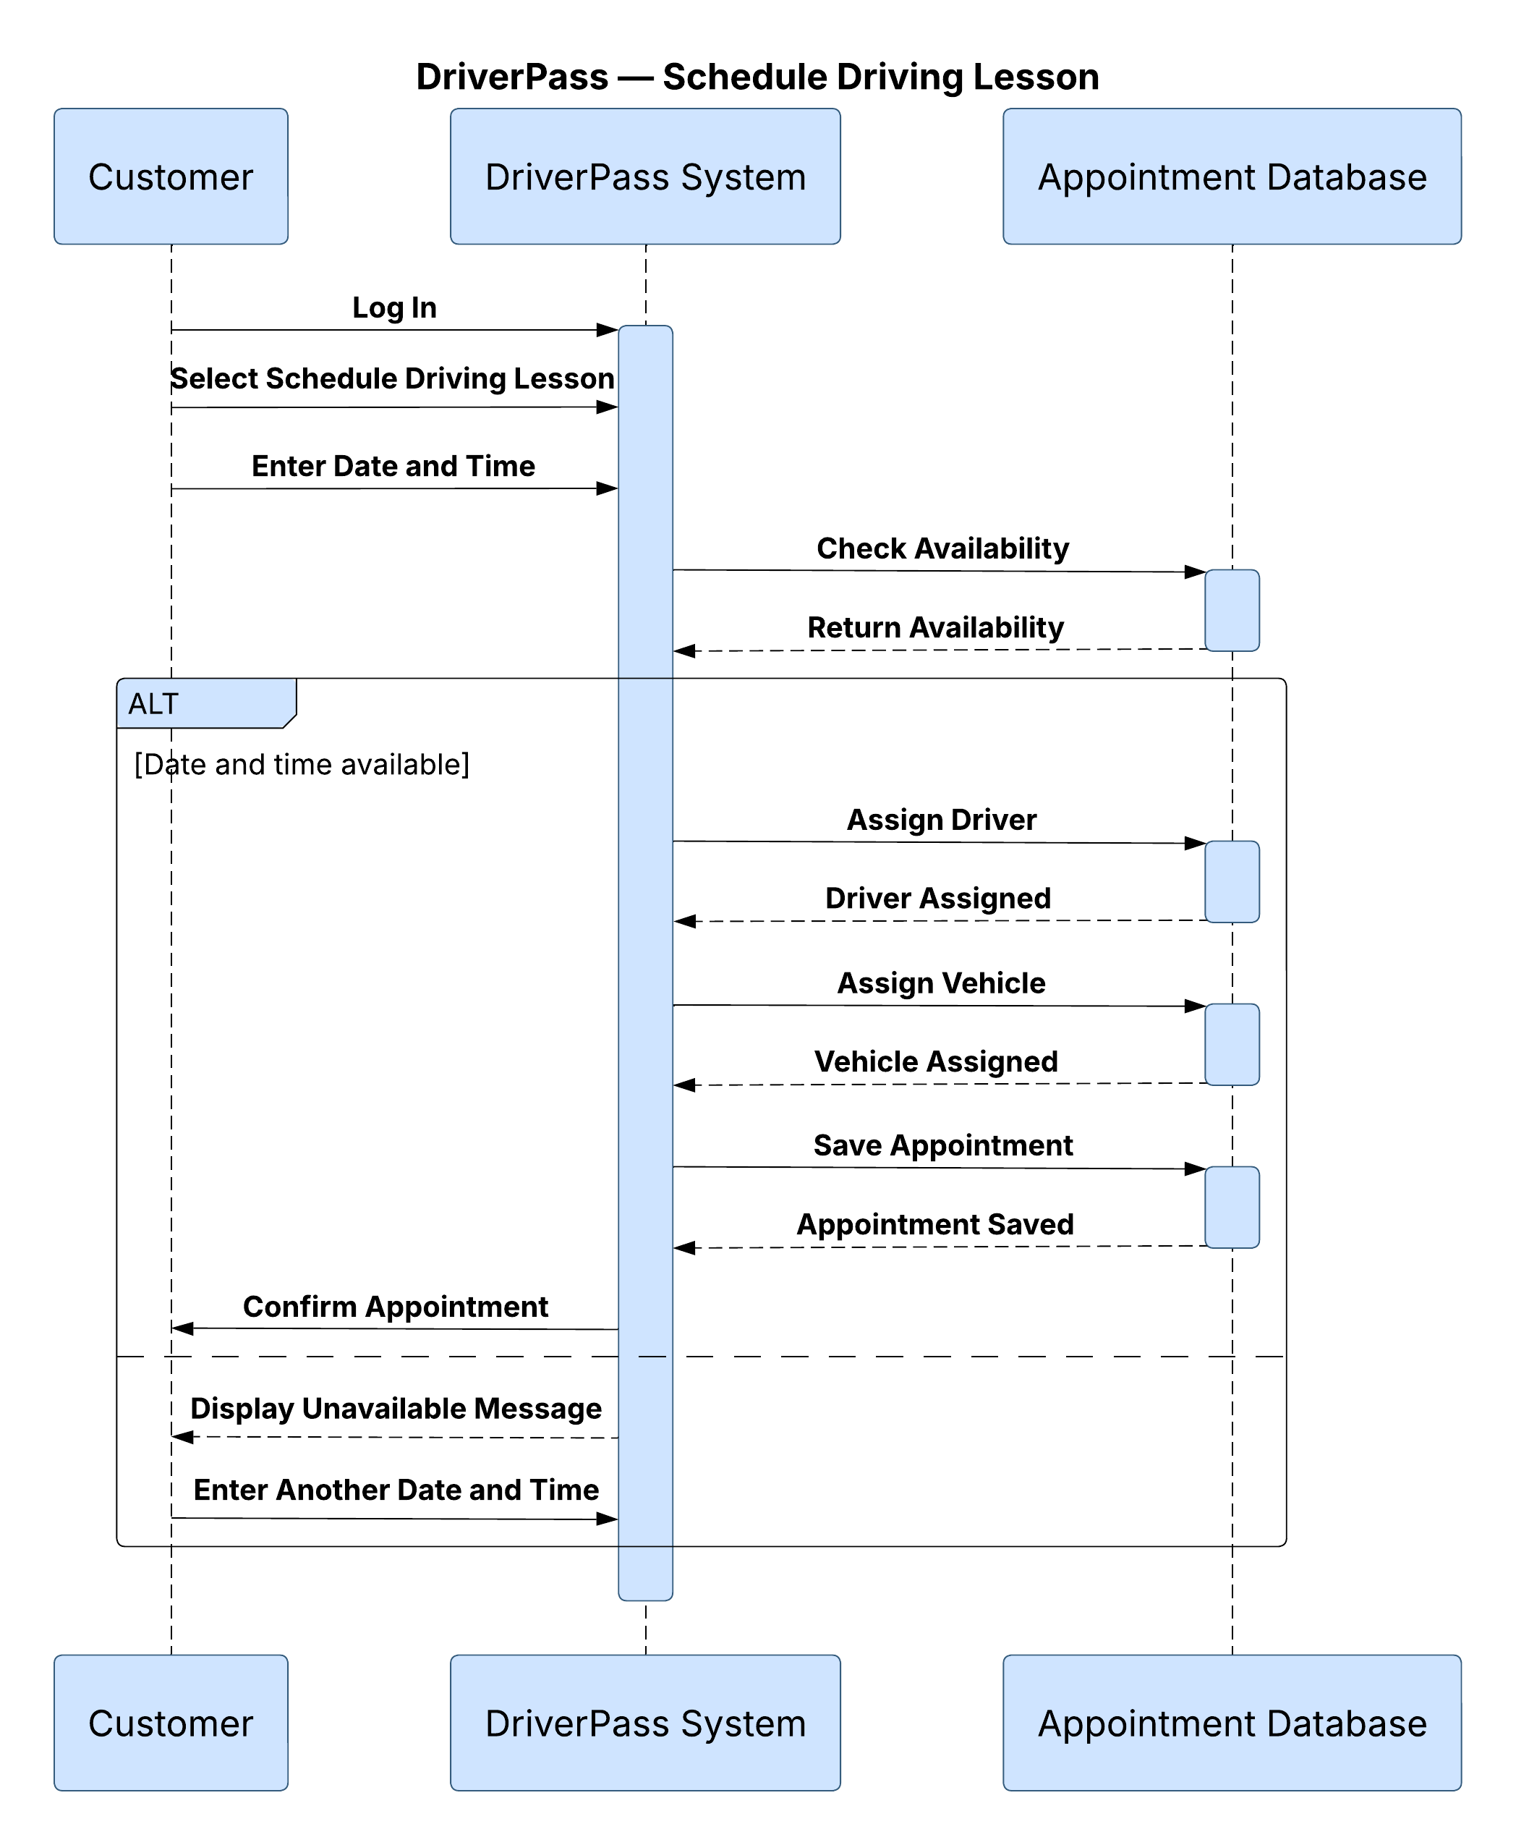

UML Class Diagram
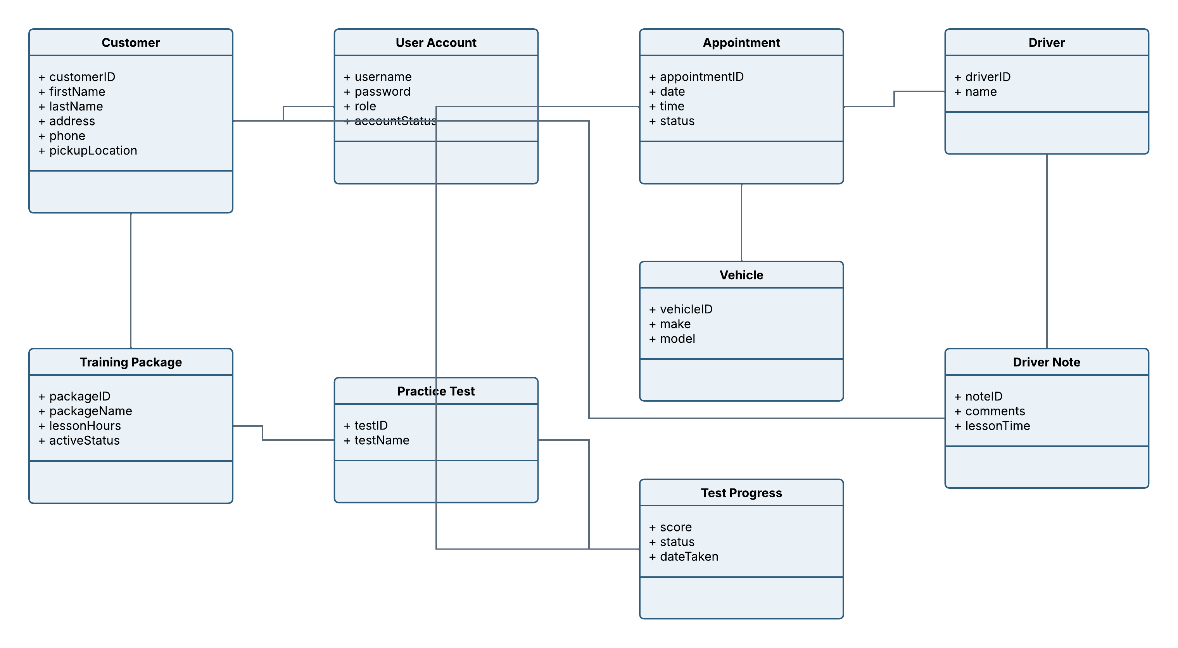

Technical Requirements

The DriverPass system needs to be a web-based application that can be accessed from both computers and mobile devices. Users will need a reliable internet connection and a current web browser to use this system. The system will also need a central database to store the customer accounts, appointments, drivers, vehicles, training packages, practice test results and other information that will be used by the application.
The system should be hosted in the cloud so DriverPass doesn’t have to manage its own servers, backups or security. User access should be controlled based on each persons role and the system should protect customer and payment information. The design does require a connection to the DMV rules so that policies and practice tests can be updated as well. Staff will need standard computers or mobile devices, and developers will need software tools for building, testing, maintaining and updating the application.

